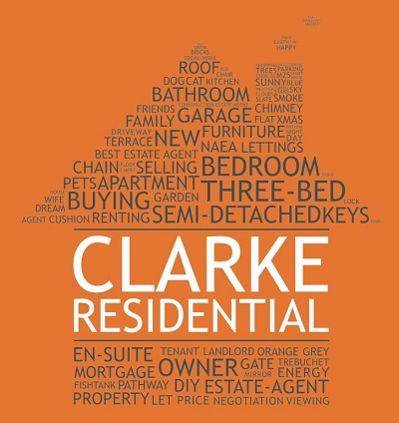

TO WHOM IT MAY CONCERN

I have known Mike Pugh for approximately 8 years, during which time he has worked for me on both personal and business projects.
Mike is a pleasure to deal with. He is efficient, helpful and overall a very genuine man.
His work is exemplary and communication is first class.
Many of my clients I have recommended have had only great things to say so I am more than happy to highly recommend Mike both on a personal and professional level.

Yours sincerely,

Jacqui Clarke MNAEA
Sales Director
Clarke Residential

07956 513238

